Subset experiments

In this document various subsets showing subtle differences between classes are shown.

FOXES  
ELEPHANTS  
LOBSTERS  
RAYS  
SLUGS VS SNAILS

# Foxes

Below you can find four different subsets of fox species.

“While the Red fox is known for its distinctive red coat of fur, it has other color variations. It can be grey, brown, red, black, or silver, but the Grey fox is a completely distinct species. The coat of a Grey fox is silvery gray with red down the chest and sides. It has white markings on the face and legs and a black stripe on the tail.

The Grey fox has a shorter and more catlike snout, shorter legs, and broader ridges on the skull. The Red fox is known for the double coat of fur that is soft underneath and coarse on top. This makes the Red fox a highly coveted animal for furriers.”[1]

“The black-tipped tail and coat color usually distinguish kit foxes from red foxes, with their white-tipped tails.” [2]

The arctic fox is noticeably different from the other foxes due to its white thick fur.

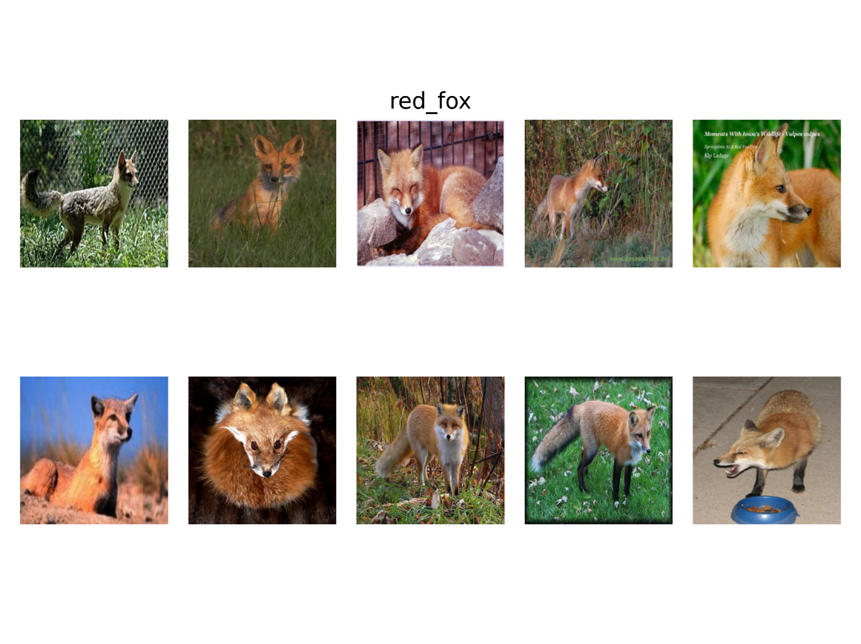

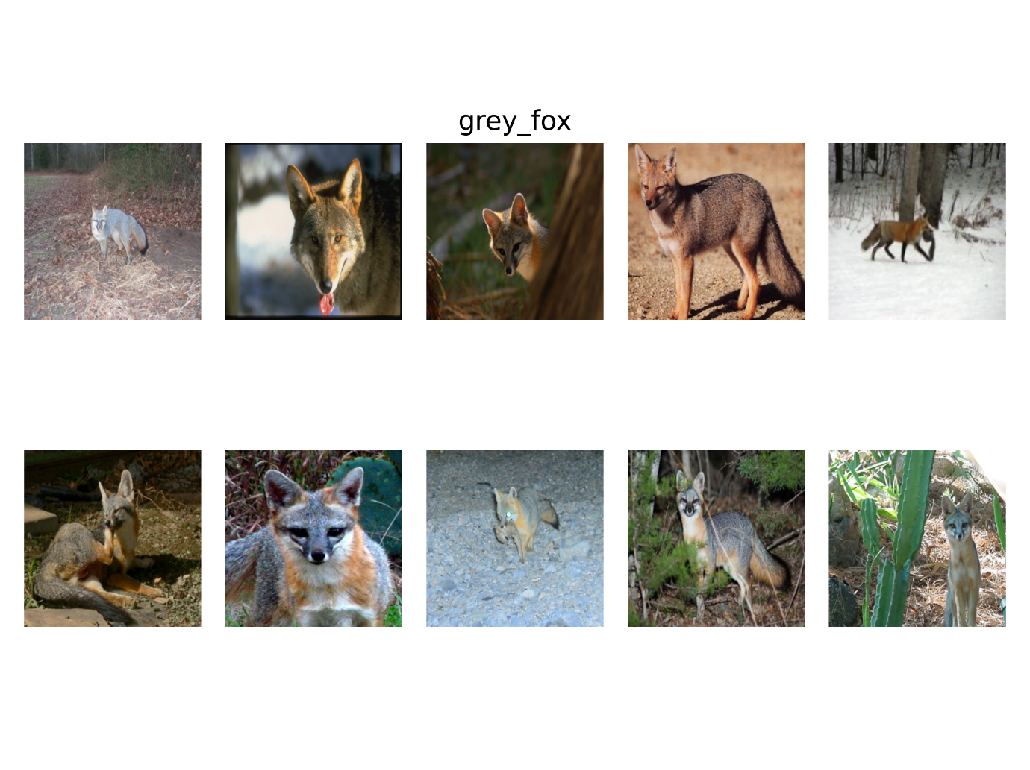

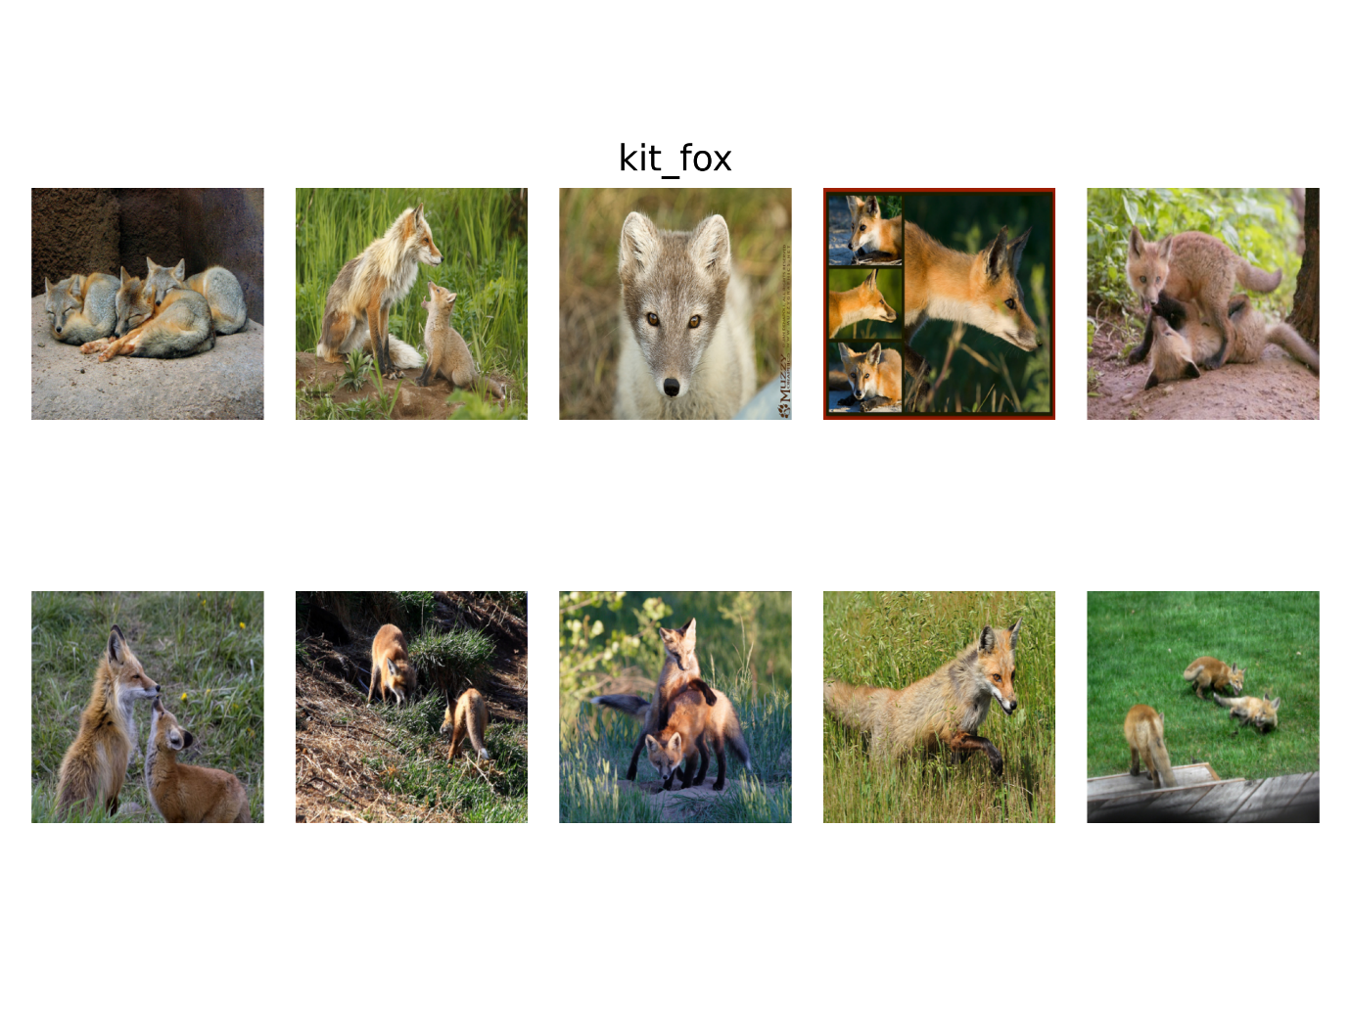

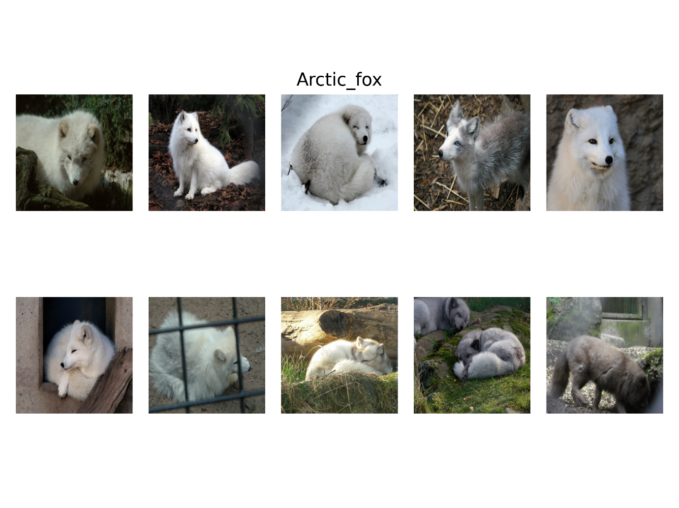

# Elephant

Asian and African elephants can be differentiated most easily by their ears, their head shape, and their tusks.

The easiest way to distinguish African elephants from Asian elephants is to look at the ears. African elephants have much larger ears that look sort of like the continent of Africa, while Asian elephants have smaller, round ears.

African elephants have rounded heads, while Asian elephants have a twin-domed head, which means there’s a divot line running up the head. Finally, you can look at the tusks. Both male and female African elephants can have tusks, but only male Asian elephants can grow them. It’s important to note, however, that not all male Asian elephants nor all African elephants necessarily develop tusks.[3]

**Concepts:**

1. Ears
2. Tusks
3. Color
4. Head shape
5. Dry grass
6. Legs
7. Water
8. Texture of skin
9. Sky

Concept 13 dry grass

Concept 5 wrinkly skin

Concept 7 trunk

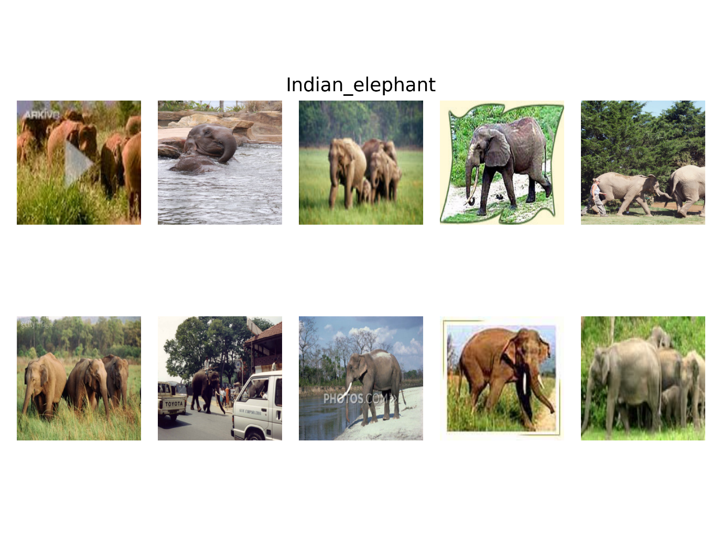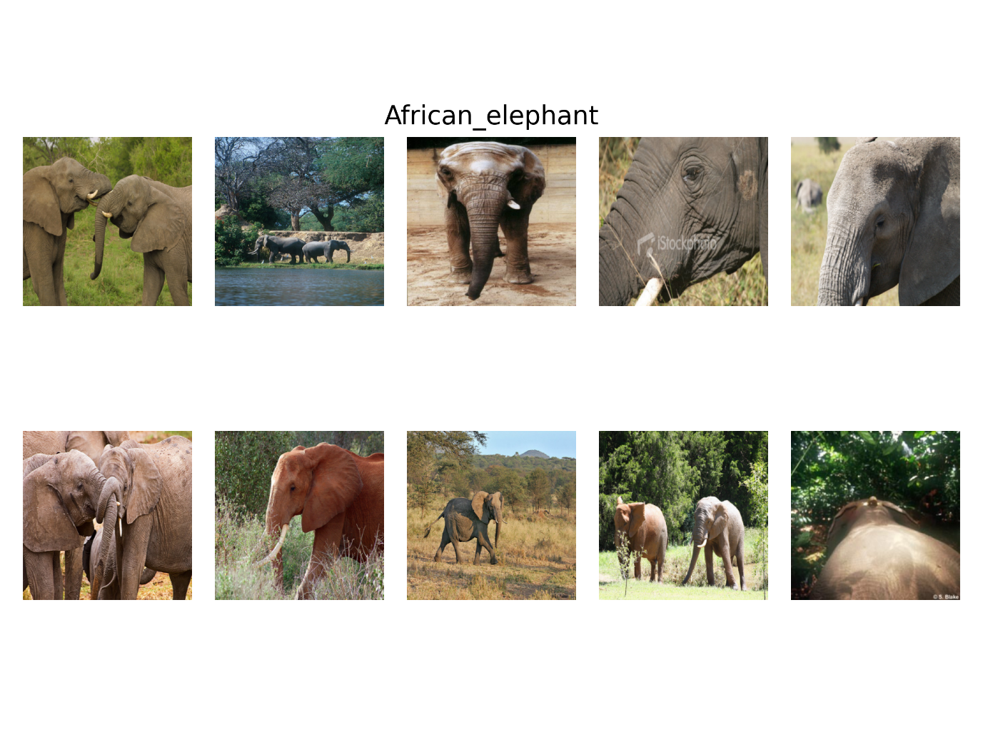

# Lobsters

The key differences between spiny lobsters and Maine lobsters are their claws and antennae. Spiny lobsters have smaller claws that are inedible and long antennae, while Maine lobsters have shorter antennae but larger claws with edible meat. They also differ in appearance, size, habitat, taste, and lifespan.

Spiny lobsters have small pointing spines covering their bodies for protection against predators, from which their name originated. They vary in color from nearly white to dark red or brown, and they often have dark-colored spots on their tail.

Maine lobsters are generally a greenish-brown or black color when alive. Some may possess a blue shell when born. They have strong claws used for feeding. Their shell has green, black, and brown spots.[4]

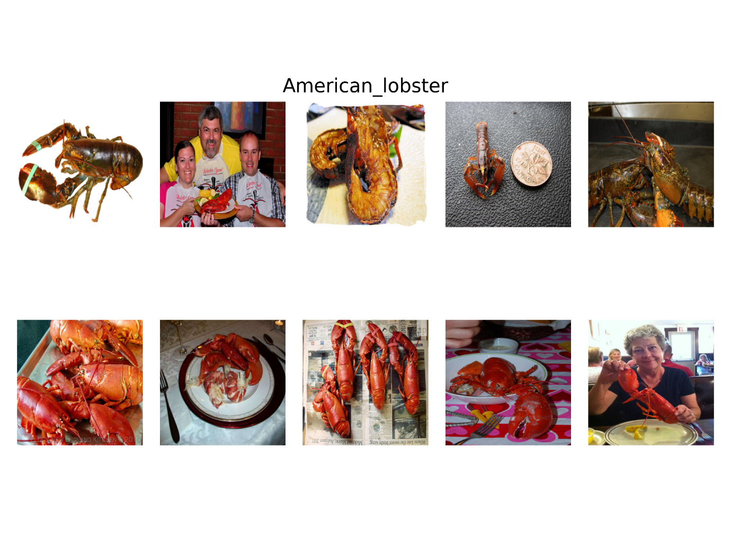

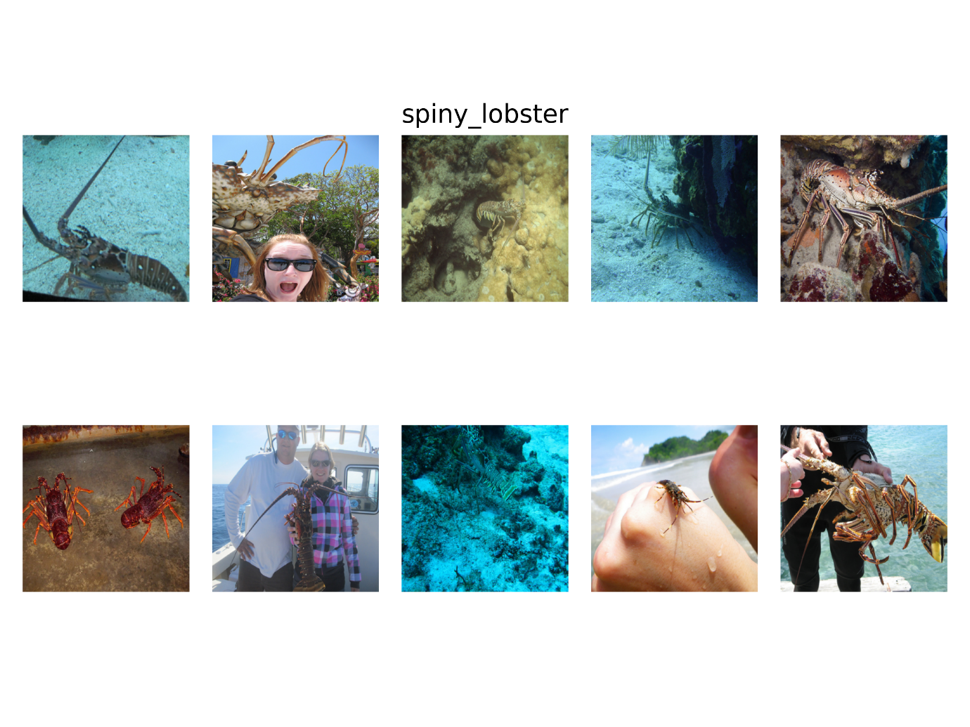

# Rays

Stingrays have a barbed stinger, and despite the negative publicity at times, these rays tend to be placid creatures that avoid contact with others. They hide under wrecks, inside caverns or on the reef and only ever sting in self-defense. Depending on the species, the stinger can be up to 35 centimetres long and has grooves that contain venom glands. Some stingrays have more than one stinger.

Electric rays are a different shape to stingrays with a stubby tail and extended, flat pectoral fins containing a pair of kidney-shaped organs. These generate an electric current, which varies from 8 volts up to 220 volts. This is used as a defense mechanism and also to immobilize prey. Sometimes strong enough to stun humans, the ancient Greeks and Romans used these fish to treat a variety of ailments.[5]

Alternatively you have a subspecies of stingray, with blue spots. We could also use this.

**Concepts:**

1. Water
2. Brown color
3. Round shape
4. Stinger
5. Blue dots

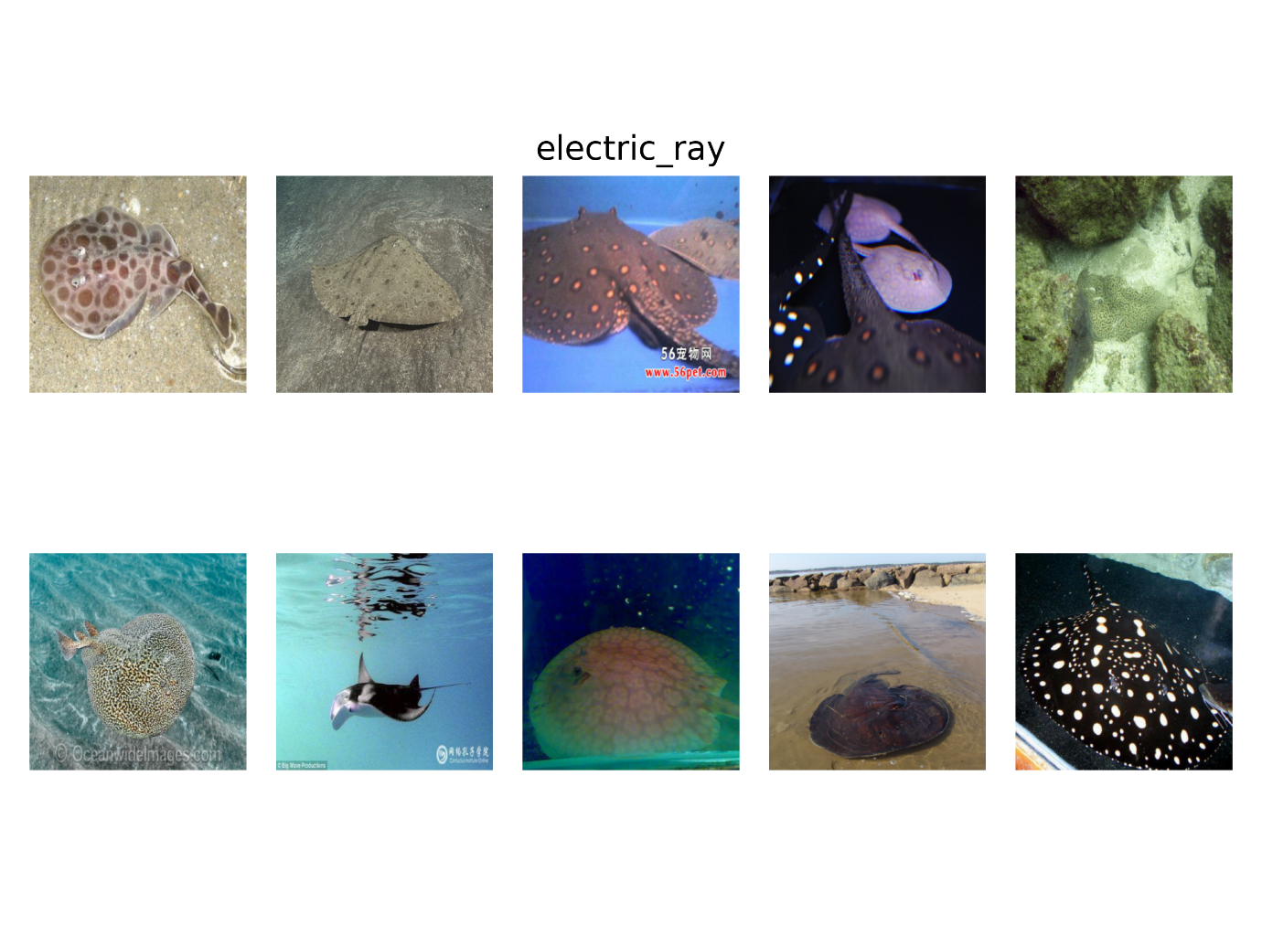

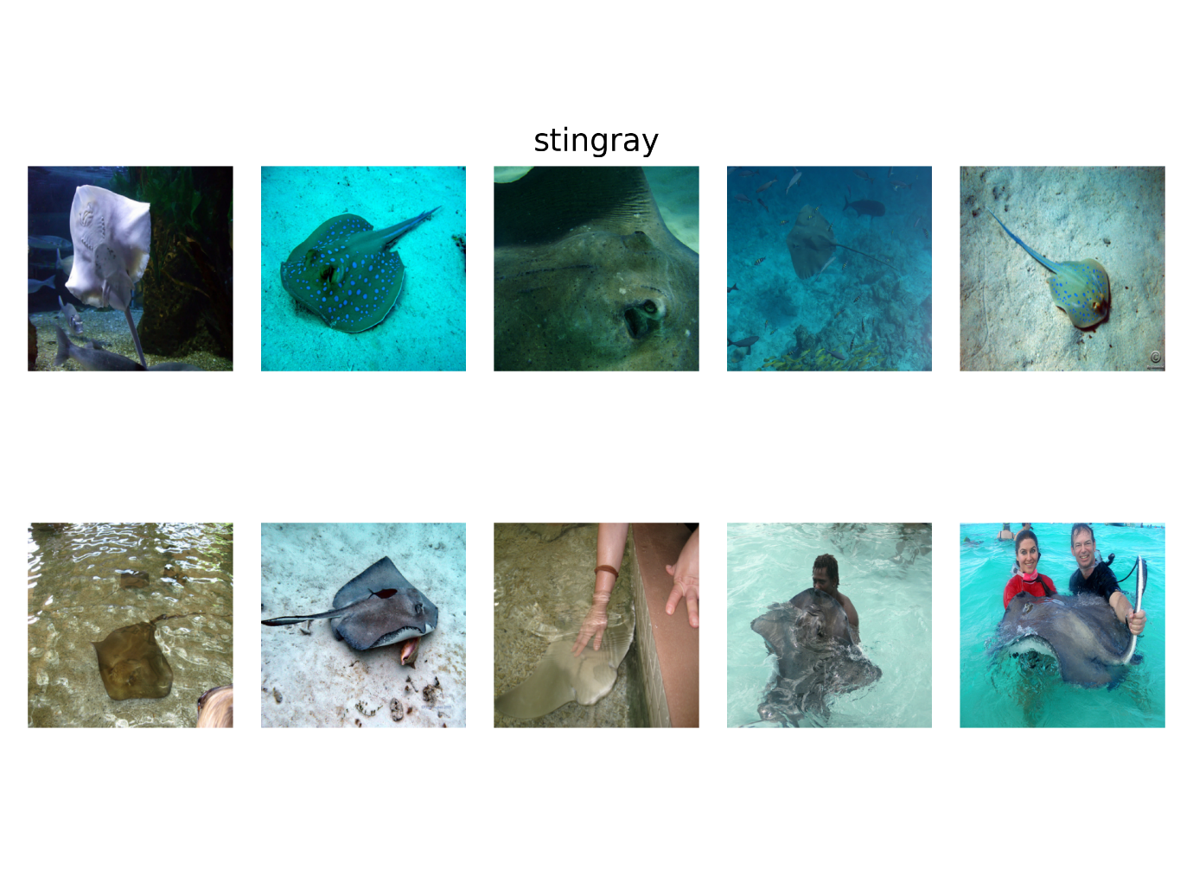

# Snail/Slug

The main difference between them is that a snail has a shell and a slug does not.[6]

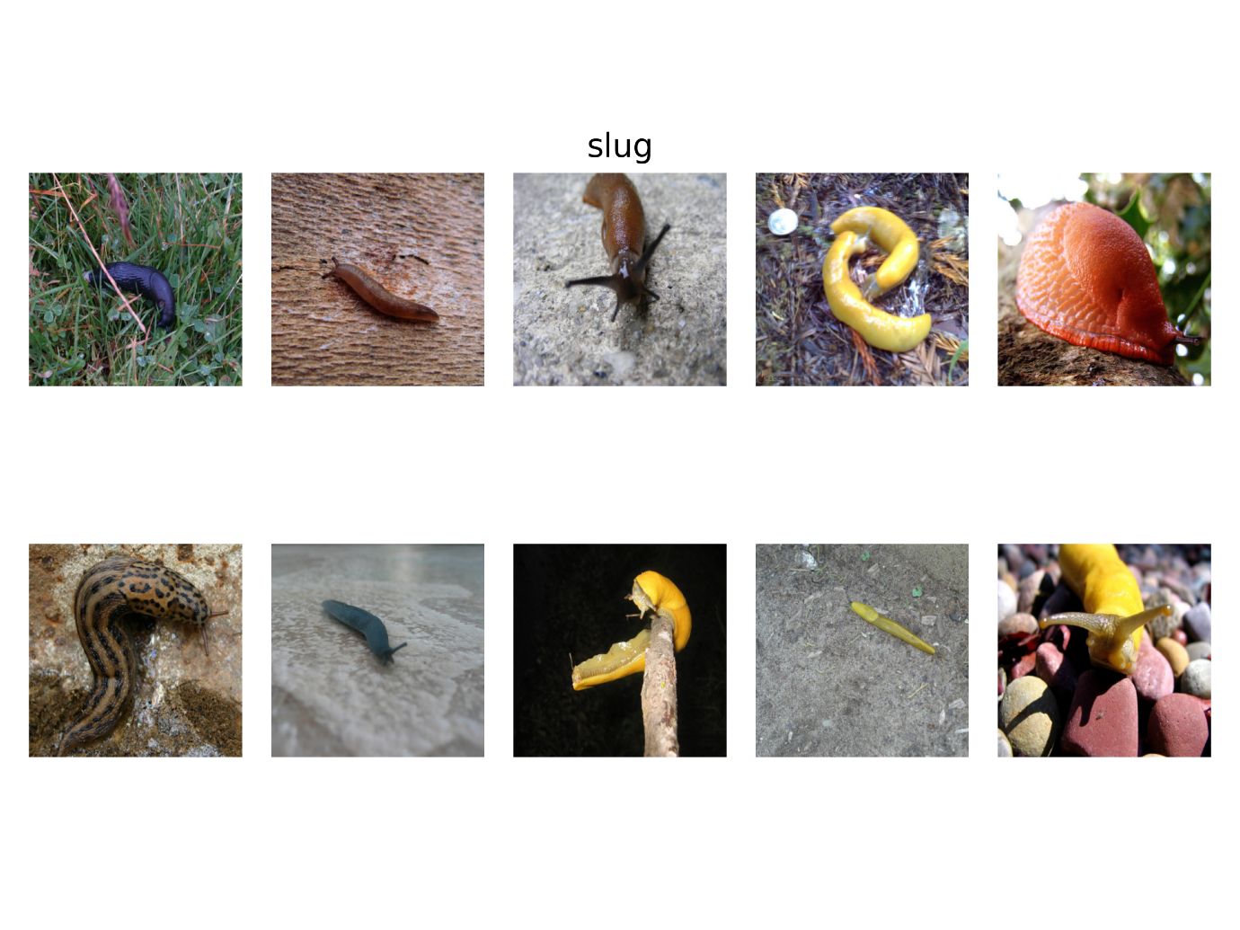

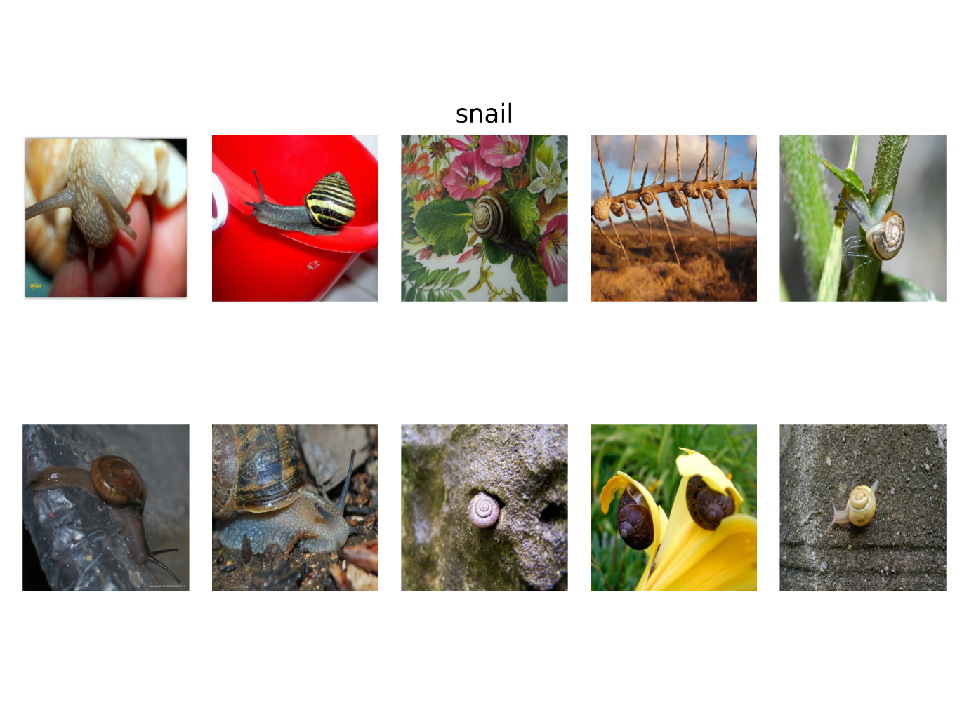

Concept 3 is zand

Concept1 is huid

Concept 6 is water

1. https://a-z-animals.com/blog/grey-fox-vs-red-fox-what-are-the-differences/
2. https://esrp.csustan.edu/speciesprofiles/profile.php?sp=vuma#:~:text=The%20black%2Dtipped%20tail%20and,thicker%20and%20has%20more%20gray.
3. https://www.britannica.com/story/whats-the-difference-between-asian-and-african-elephants#:~:text=The%20easiest%20way%20to%20distinguish,elephants%20have%20smaller%2C%20round%20ears.
4. https://a-z-animals.com/blog/spiny-lobster-vs-maine-lobster-what-are-the-differences/
5. http://www.seafocus.com/species_stingrays.html
6. https://kids.britannica.com/kids/article/snail-and-slug/353784#:~:text=The%20main%20difference%20between%20them,on%20land%20or%20in%20trees.